

**TAYLOR’S UNIVERSITY**

**FOUNDATION IN COMPUTING**

**ITS30305 WEB PROGRAMMING**

**Assignment 1**

**(Individual Assignment)**



**Foundation in Computing**

**ITS30305 Web Programming**

**Assignment 1**

**(Individual Assignment)**

**Hand out Date: 24th October 2017 (Tuesday)**

**Hand in Date: 8th November 2017 (Wednesday)**

**Presentation time: 7th/8th November 2017 (During class time)**

**Weightage: 15%**

**Instructions to students:**

* The assignment should be attempted individually
* Complete this cover sheet and attach it to your assignment – this should be your first page!

|  |  |
| --- | --- |
| **Student declaration:** | |
| ***I declare that:***   1. ***I understand what is meant by plagiarism*** 2. ***The implication of plagiarism have been explained to us by our lecturer***   ***This project is all our work and I have acknowledged any use of the published or unpublished works of other people.*** | |
| **Name (Student ID)** | **Signature** |
| **Ng Ruey Xin (0331805)** |  |

*Avoid copy and paste job in your report and it is considered as plagiarism. Plagiarism in all forms is forbidden. Students who submit plagiarised assignment will deserved a 0 marks.*

TABLE OF CONTENTS

Introduction 1

Purpose of the Website 1

Target Audience 1

Website design 2

Site Map 2

Story Board 3

Appendix 4

Screen Captures #

Source Code #

References #

List of Referencing #

**INTRODUCTION**

I had made a website, named Travel .life, which means “Travel all around the world in your life”. Basically, this is a website that provides you information about different country and the things to do at there. Travel .life is tourism website which promote the several country in Europe. It is also let more people know about the places in those countries. So, Travel .life provides you the information and recommendation about the Europe country.

Purpose of this website

* Let more people know about the beauty of those country
* Inspire you the scenery of the countries
* Increase your knowledge about different country
* Relax yourself

Target Audience

Target audience for this website will be the community who are planning to have a holiday, as the post in this website are open and no age restrictions.

**WEBSITE DESIGN**

Site Map

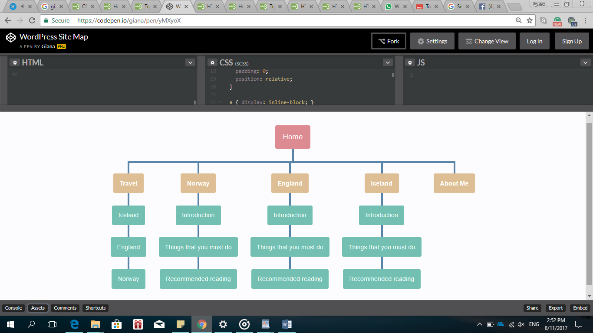

Story Board

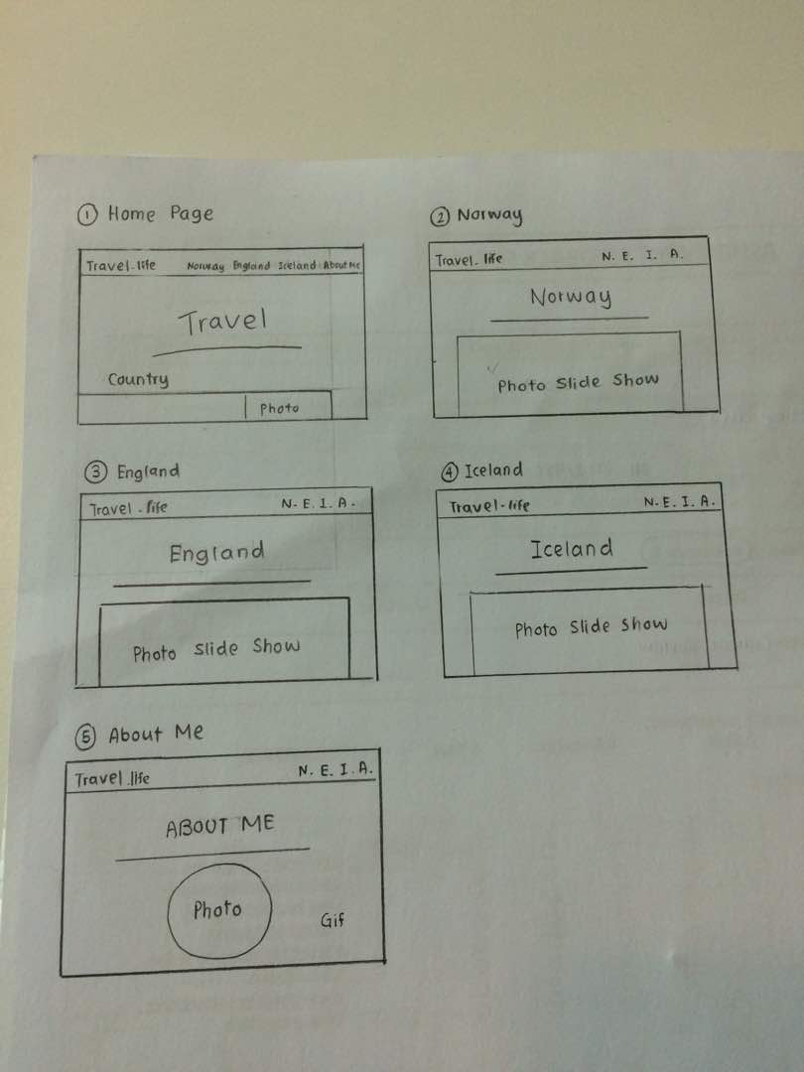

**APPENDIX**

Screen Capture

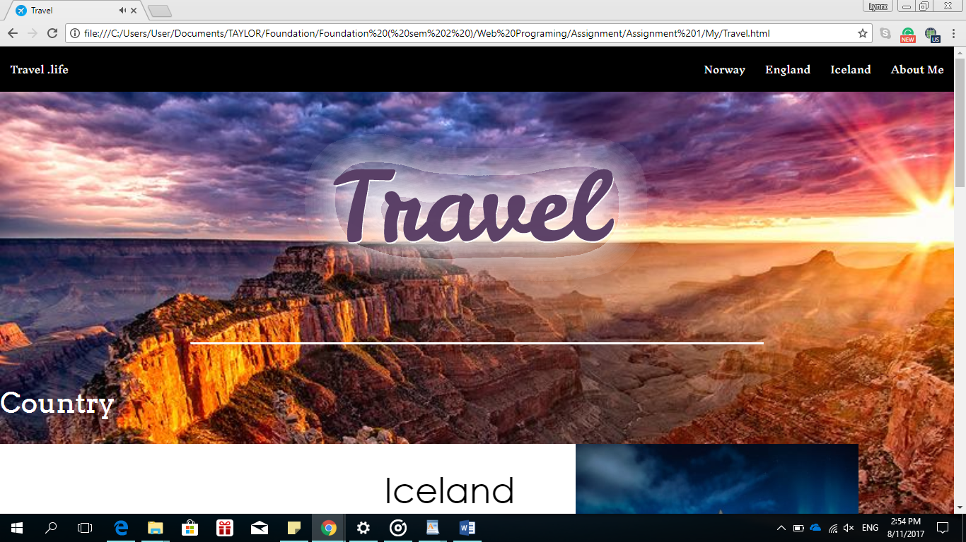

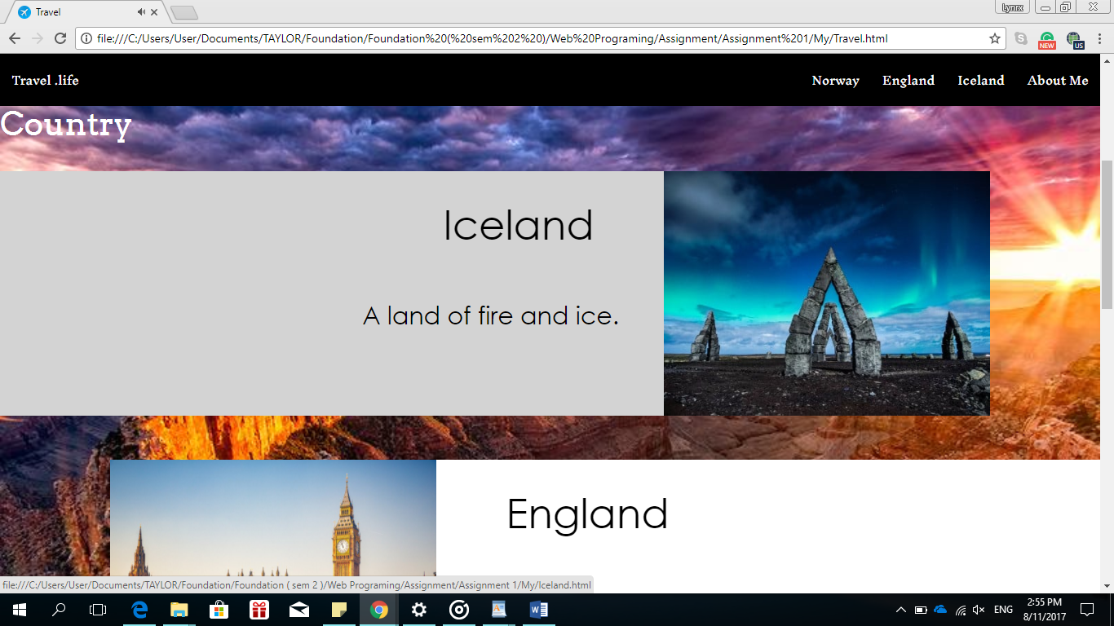

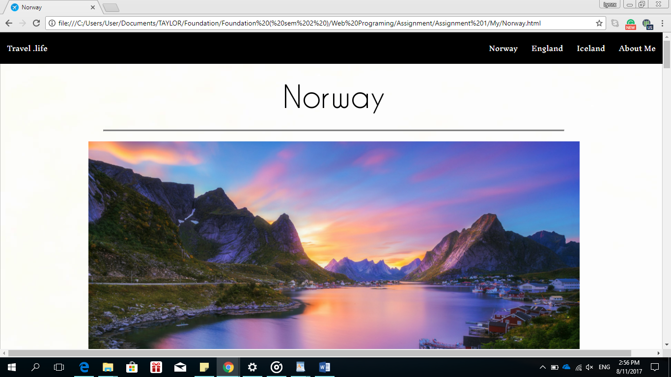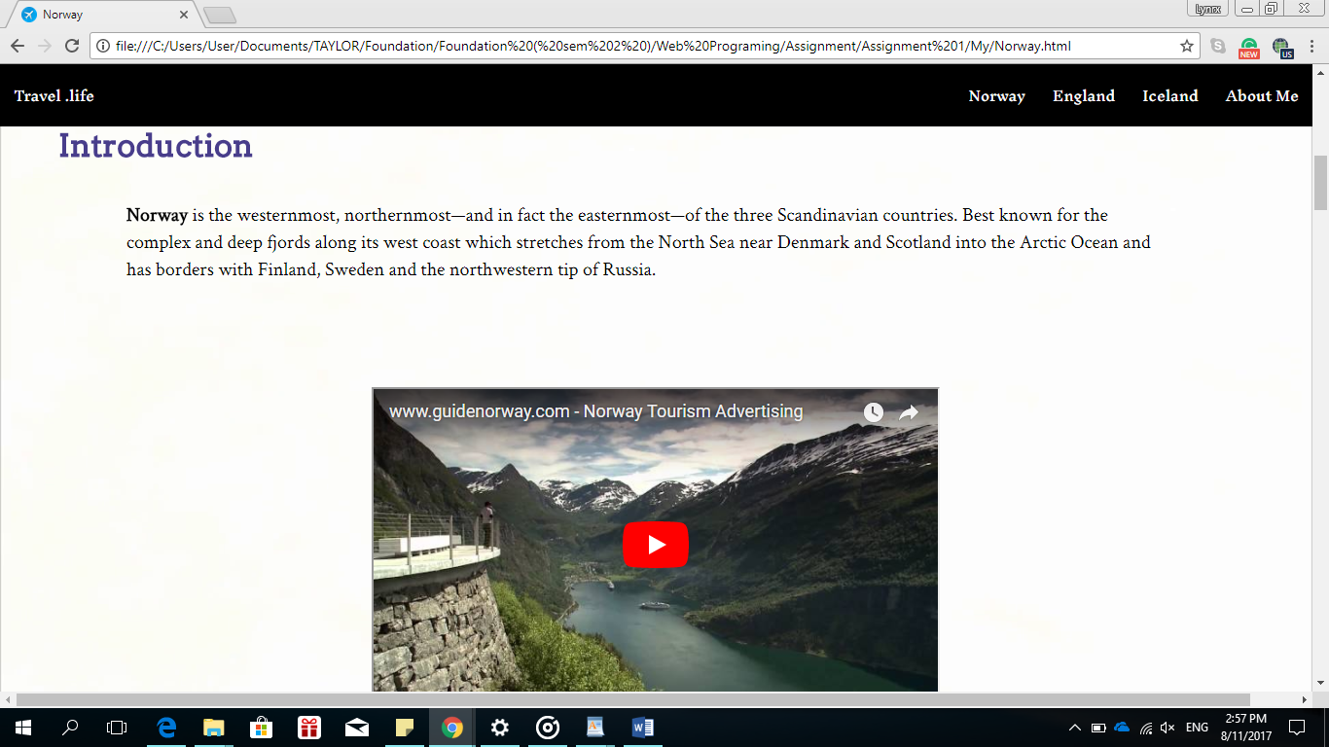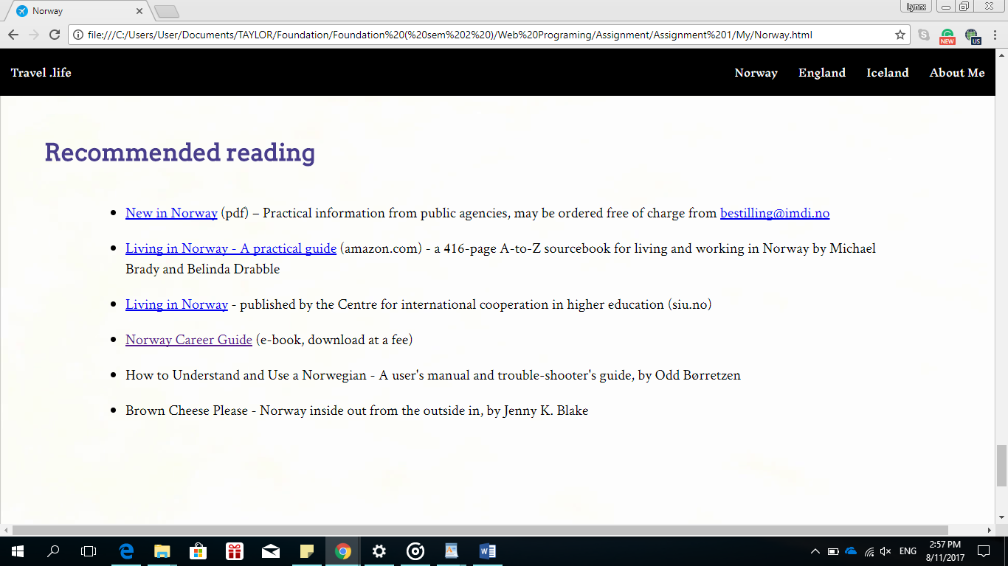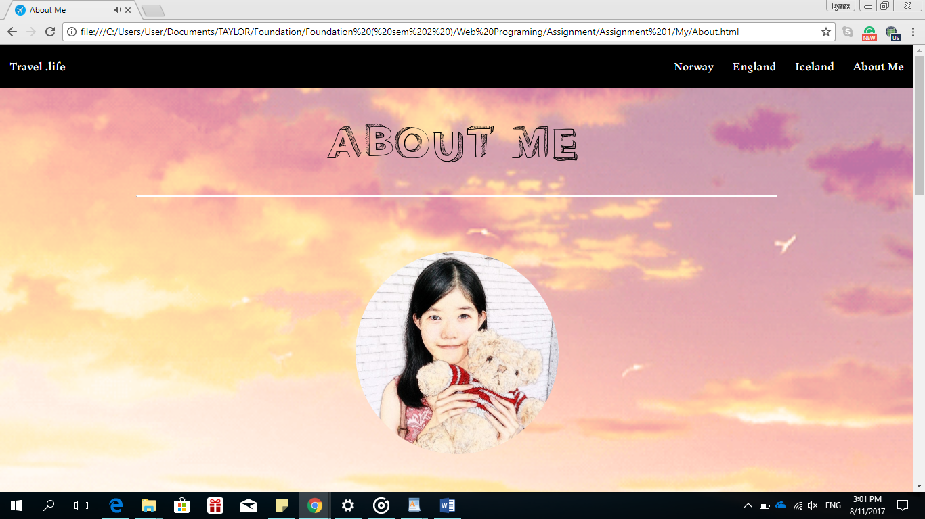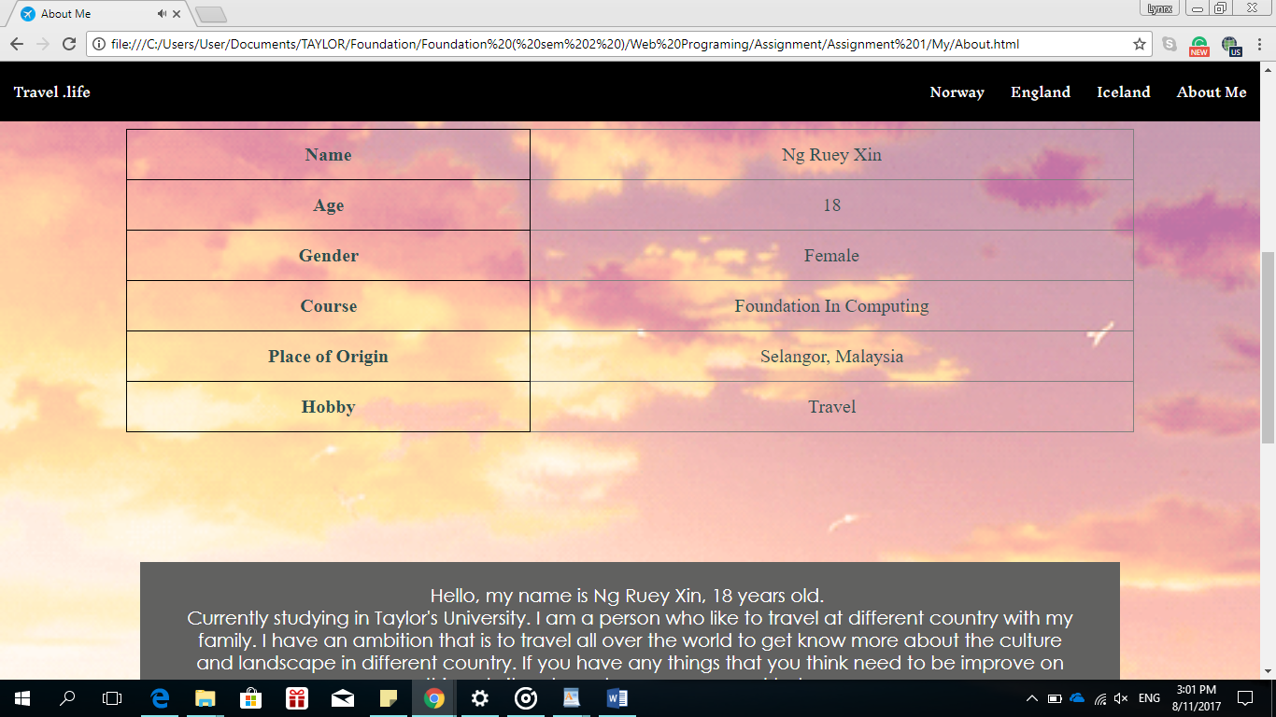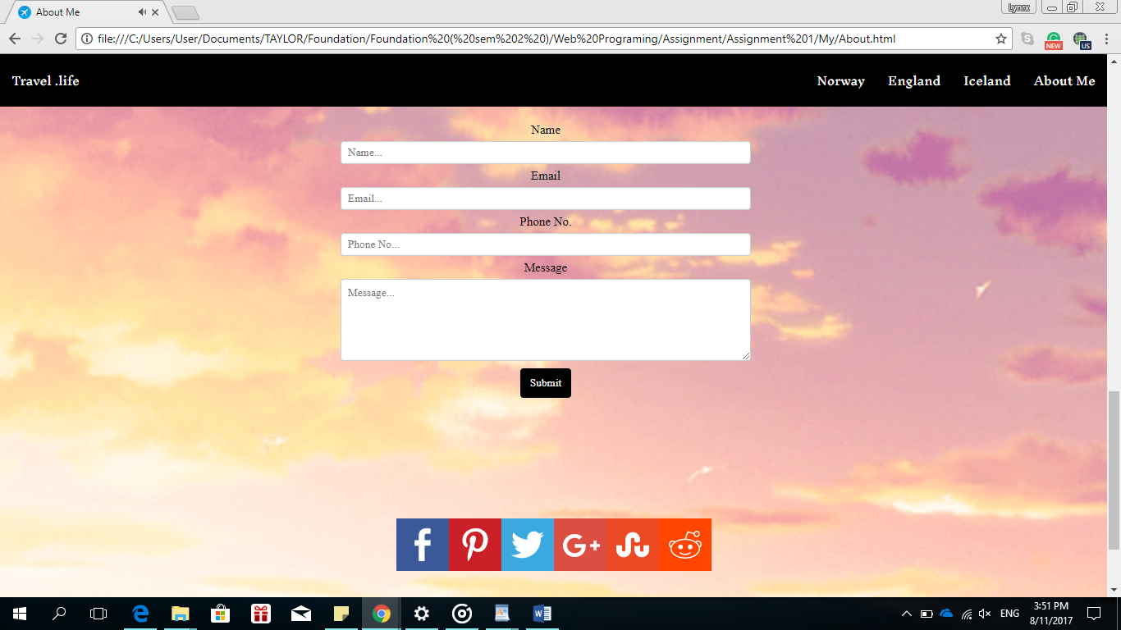

Source Code

Travel.html

<!DOCTYPE html>

<html>

<head>

<meta charset="UTF-8">

<title> Travel</title>

<link rel="shortcut icon" href="http://theinspirationroom.com/daily/design/2015/9/google_travel_logo.png" />

<link rel="stylesheet" href=â€œstyle.css">

<link rel="stylesheet" href="tra.css">

<link href='https://fonts.googleapis.com/css?family=Arvo' rel='stylesheet'>

<link href='https://fonts.googleapis.com/css?family=Inknut Antiqua' rel='stylesheet'>

</head>

<style>

</style>

<body>

<div class="topnav" id="myTopnav" >

<a href=About.html>About Me</a>

<a href=Iceland.html>Iceland</a>

<a href=England.html>England</a>

<a href=Norway.html>Norway</a>

<a style="float:left" href=Travel.html >Travel .life</a>

</div>

<br><br>

<div class="Main">

<img src=Travel.png height= â€œ400â€ width= â€œ800â€/>

</div>

<a href="#start" class="scrollTo"><div class="icon-scroll opacity-0-3 hover-opacity-1-0"></div></a>

<hr>

<br>

<div class="Country">

<h2 align="left">Country</h2>

</div>

<a href=Iceland.html>

<div class="Iceland" id="Iceland">

<h1 margin-right=â€œ20pxâ€>Iceland</h1>

<img src=Icelandimg.jpg class="Icelandimg" height= "300" width= "400"/>

<h3>A land of fire and ice.</h3>

</div>

</a>

<br><br><br>

<a href=England.html>

<div class="England" id="England">

<h1>England</h1>

<img src=Englandimg.jpg class="Englandimg" height= "300" width= "400"/>

<h4>A downright intriguing place on Earth.</h4>

</div>

</a>

<br><br><br><br><br><br><br><br><br><br><br><br><br><br><br><br><br><br><br><br>

<a href=Norway.html>

<div class="Norway" id="Norway">

<h1>Norway</h1>

<img src=Norwayimg.png class="Norwayimg" height= "300" width= "400"/>

<h5>A once-in-a-lifetime destination</h5>

</div>

</a>

<br><br><br>

<section id="contact" style="background-color:white;">

<div class="contact">

<div id="form">

<form action=" id="contactForm" method="post"><br/>

<span>&emsp; Name</span>

<input type="text" name="name" class="name" placeholder="Enter your name" tabindex=1 />

<span>Email</span>

<input type="text" name="email" class="email" placeholder="Enter your email" tabindex=2 />

<span id="captcha"></span>

<input type="text" name="captcha" class="captcha" maxlength="4" size="4" placeholder="Enter captcha code" tabindex=3 />

<span>Message</span>

<textarea class="message" placeholder="Enter your message" tabindex=4></textarea>

<input type="submit" name="submit" value="Send e-mail" class="submit" tabindex=5><br/>

</form>

</div>

</section>

<p align="center"><br><a data-site="" class="ssba_facebook_share" href="http://www.facebook.com/sharer.php?u=http://awesomejelly.com/20-best-college-life-hacks-that-every-college-student-needs/" target="_blank"><img src="http://awesomejelly.com/wp-content/plugins/simple-share-buttons-adder/buttons/simple/facebook.png" title="Facebook" class="ssba ssba-img" alt="Share on Facebook"></a><a data-site="pinterest-featured" href="http://pinterest.com/pin/create/bookmarklet/?is_video=false&amp;url=http://awesomejelly.com/20-best-college-life-hacks-that-every-college-student-needs/&amp;media=http://awesomejelly.com/wp-content/uploads/2016/08/college-hack-feat.jpg&amp;description=20 Smart College Life Hacks That Every College Student Needs To Know" class="ssba_pinterest_share ssba_share_link" target="&quot;_blank&quot;"><img src="http://awesomejelly.com/wp-content/plugins/simple-share-buttons-adder/buttons/simple/pinterest.png" title="Pinterest" class="ssba ssba-img" alt="Pin on Pinterest"></a><a data-site="" class="ssba_twitter_share" href="http://twitter.com/share?url=http://awesomejelly.com/20-best-college-life-hacks-that-every-college-student-needs/&amp;text=20%20Smart%20College%20Life%20Hacks%20That%20Every%20College%20Student%20Needs%20To%20Know%20" target="&quot;_blank&quot;"><img src="http://awesomejelly.com/wp-content/plugins/simple-share-buttons-adder/buttons/simple/twitter.png" title="Twitter" class="ssba ssba-img" alt="Tweet about this on Twitter"></a><a data-site="" class="ssba_google_share" href="https://plus.google.com/share?url=http://awesomejelly.com/20-best-college-life-hacks-that-every-college-student-needs/" target="&quot;_blank&quot;"><img src="http://awesomejelly.com/wp-content/plugins/simple-share-buttons-adder/buttons/simple/google.png" title="Google+" class="ssba ssba-img" alt="Share on Google+"></a><a data-site="stumbleupon" class="ssba_stumbleupon_share ssba_share_link" href="http://www.stumbleupon.com/submit?url=http://awesomejelly.com/20-best-college-life-hacks-that-every-college-student-needs/&amp;title=20%20Smart%20College%20Life%20Hacks%20That%20Every%20College%20Student%20Needs%20To%20Know" target="&quot;_blank&quot;"><img src="http://awesomejelly.com/wp-content/plugins/simple-share-buttons-adder/buttons/simple/stumbleupon.png" title="StumbleUpon" class="ssba ssba-img" alt="Share on StumbleUpon"></a><a data-site="reddit" class="ssba_reddit_share" href="http://reddit.com/submit?url=http://awesomejelly.com/20-best-college-life-hacks-that-every-college-student-needs/&amp;title=20 Smart College Life Hacks That Every College Student Needs To Know" target="&quot;_blank&quot;"><img src="http://awesomejelly.com/wp-content/plugins/simple-share-buttons-adder/buttons/simple/reddit.png" title="Reddit" class="ssba ssba-img" alt="Share on Reddit"></a></p>

<hr>

</body>

<audio controls autoplay hidden>

<source src="Piano.mp3" type="audio/mp3">

</audio>

<div class="footer">

<p>Copyright @ 2017 Travel .life</p>

</div>

</html>

**Travel CSS**

body {background-image: url(Travelimg.jpg);

background-repeat: no-repeat;

background-position: right top;

background-attachment: fixed;

margin:0px;

background-size: cover;

text-align:center;

}

h1 {font-family: "Century Gothic", CenturyGothic, AppleGothic, san-serif;

font-size: 50px;

font-style: normal;

font-weight: 500;

color: white;

line-height: auto 0px;}

h2 { font-family:'Arvo';

font-size: 40px;

font-style: normal;

font-weight: 500;

color: white;}

h3 {font-family: "Century Gothic", CenturyGothic, AppleGothic, san-serif;

float: right;

color: black;

align: right;

font-style: normal;

font-size: 30px;

font-weight: 500;

width: 35%;}

h4 {font-family: "Century Gothic", CenturyGothic, AppleGothic, san-serif;

float: left;

color: black;

align: left;

font-style: normal;

font-size: 30px;

font-weight: 500;

width: 60%;}

h5 {font-family: "Century Gothic", CenturyGothic, AppleGothic, san-serif;

float: right;

color: black;

align: right;

font-style: normal;

font-size: 30px;

font-weight: 500;

width: 60%;}

hr {border-top: 2px solid white;

width: 60%;

margin-top:60px;}

.country {background-color: black;

width:20%;

font-family: 'Headland One';}

.topnav {background-color: black;

width: 100%;

position:fixed;}

.topnav a {font-family: 'Inknut Antiqua';

float: right;

color: white;

text-align: center;

padding: 14px ;

text-decoration: none;

font-size: 14px;}

.topnav b {font-family: 'Inknut Antiqua';

float: left;

display: block;

color: white;

text-align: left;

padding: 14px 16px;

font-size: 14px;}

.topnav a:hover {background-color: white;

color: black;}

.footer {

position: bottom;

left: 0;

bottom: 0;

width: 100%;

color: white;

text-align: center;

font-style: normal;

font-size: 15px;

font-weight: 600;

background-color: #292c2f;

box-shadow: 0 1px 1px 0 rgba(0, 0, 0, 0.12);

box-sizing: border-box;

width: 100%;

text-align: center;

font: normal 20px sans-serif;

padding: 10px 10px;

margin-top: 40px;

}

.Iceland {background-color: white;

overflow: auto;

width:90%;}

.Iceland:hover {background-color: lightgrey;}

.Iceland h1 {text-align: right;

float: left;

color:black;

width: 60%;}

.Icelandimg {float: right;}

.England:hover {background-color: lightgrey;}

.England {float:right;

width:90%;

background-color:white;}

.England h1 {text-align: left;

float:right;

color:black;

width: 60%;}

.Englandimg{float: left;}

.Norway:hover {background-color: lightgrey;}

.Norway {background-color: white;

overflow: auto;

width:90%;}

.Norway h1 {text-align: right;

float: left;

color:black;

width: 60%;}

.Norwayimg {float: right;}

.Iceland{-webkit-animation: fadein 2s;

-moz-animation: fadein 2s;

-ms-animation: fadein 2s;

-o-animation: fadein 2s;

animation: fadein 2s;}

@keyframes fadein {from { opacity: 0; }

to { opacity: 1; }}

@-moz-keyframes fadein {from { opacity: 0; }

to { opacity: 1; }}

@-webkit-keyframes fadein {from { opacity: 0; }

to { opacity: 1; }}

@-ms-keyframes fadein {from { opacity: 0; }

to { opacity: 1; }}

@-o-keyframes fadein {from { opacity: 0; }

to { opacity: 1; }}

.England{-webkit-animation: fadein 2s;

-moz-animation: fadein 2s;

-ms-animation: fadein 2s;

-o-animation: fadein 2s;

animation: fadein 2s;}

@keyframes fadein {from { opacity: 0; }

to { opacity: 1; }}

@-moz-keyframes fadein {from { opacity: 0; }

to { opacity: 1; }}

@-webkit-keyframes fadein {from { opacity: 0; }

to { opacity: 1; }}

@-ms-keyframes fadein {from { opacity: 0; }

to { opacity: 1; }}

@-o-keyframes fadein {from { opacity: 0; }

to { opacity: 1; }}

.Norway{-webkit-animation: fadein 2s;

-moz-animation: fadein 2s;

-ms-animation: fadein 2s;

-o-animation: fadein 2s;

animation: fadein 2s;}

@keyframes fadein {from { opacity: 0; }

to { opacity: 1; }}

@-moz-keyframes fadein {from { opacity: 0; }

to { opacity: 1; }}

@-webkit-keyframes fadein {from { opacity: 0; }

to { opacity: 1; }}

@-ms-keyframes fadein {from { opacity: 0; }

to { opacity: 1; }}

@-o-keyframes fadein {from { opacity: 0; }

to { opacity: 1; }}

.Main{-webkit-animation: fadein 2s;

-moz-animation: fadein 2s;

-ms-animation: fadein 2s;

-o-animation: fadein 2s;

animation: fadein 2s;}

@keyframes fadein {from { opacity: 0; }

to { opacity: 1; }}

@-moz-keyframes fadein {from { opacity: 0; }

to { opacity: 1; }}

@-webkit-keyframes fadein {from { opacity: 0; }

to { opacity: 1; }}

@-ms-keyframes fadein {from { opacity: 0; }

to { opacity: 1; }}

@-o-keyframes fadein {from { opacity: 0; }

to { opacity: 1; }}

.Main{margin-top:60px;}

.form {

background-color: #B1B1B1;

margin: 15px auto 0;

width: 410px;

float: center;

align:center;

}

#contact {

overflow: auto;

}

#contact #form {

width:410px;

float:left;

}

#contact #form h2 {

font: 48px 'Bree Serif', Georgia, serif;

}

#contact #form span {

display:block;

float:left;

width:100px;

padding-top:5px;

font: 14px/16px'Bree Serif', Georgia, serif;

}

#contact #form input {

float:left;

width:255px;

border:0px;

color:#F1F1F1;

padding:10px 10px 10px 30px;

font: 11px/20px'Open Sans', Verdana, Helvetica, sans-serif;

margin-bottom:10px;

}

#contact #form textarea {

float:left;

border:0px;

width:255px;

height:140px;

padding:10px 10px 10px 30px;

font: 11px/20px'Open Sans', Verdana, Helvetica, sans-serif;

color:#F1F1F1;

resize: none;

}

#contact #form input.name {

background:#222222 url(http://img7.uploadhouse.com/fileuploads/17737/177370145f09fe433945815665aa214f80dbc6af.png) no-repeat 10px 8px;

}

#contact #form input.email {

background:#222222 url(http://img6.uploadhouse.com/fileuploads/17737/177370138cc63992182149e9befabff3eafa6d23.png) no-repeat 10px 9px;

}

#contact #form input.captcha {

background:#222222 url(http://img3.uploadhouse.com/fileuploads/17737/17737011310213e71805ecf2292144cbbecf42ad.png) no-repeat 10px 9px;

}

#contact #form textarea.message {

background:#222222 url(http://img3.uploadhouse.com/fileuploads/17737/1773701229ed8c2f465a8274623ca8976adaf196.png) no-repeat 10px 8px;

}

#contact #form input.submit {

cursor: pointer;

width:85px;

height:30px;

float:right;

padding:0px 0px 5px 0px;

margin:10px 16px 0px 0px;

background:#222222;

color:#F1F1F1;

font: 14px/16px'Bree Serif', Georgia, serif;

}

#contact #captcha span{

width: 44px;

}

#contact #captcha input{

background: url(http://img3.uploadhouse.com/fileuploads/17737/17737011310213e71805ecf2292144cbbecf42ad.png) no-repeat scroll 0 0 transparent;

margin: 5px 0 0;

padding: 0;

border: medium none;

cursor: pointer;

width: 15px;

}

**Norway**

<!DOCTYPE html>

<html>

<head>

<title>Norway</title>

<link rel="icon" href="http://theinspirationroom.com/daily/design/2015/9/google_travel_logo.png">

<link href='https://fonts.googleapis.com/css?family=Arvo' rel='stylesheet'>

<link href='https://fonts.googleapis.com/css?family=Crimson Text' rel='stylesheet'>

<link href='https://fonts.googleapis.com/css?family=Inknut Antiqua' rel='stylesheet'>

</head>

<style>

body{

background-image: url("background4.png");

background-repeat:no-repeat;

background-position:center;

background-attachment:fixed;

margin-top:0px;

margin-bottom:0px;

margin-right:0px;

margin-left:0px;

height:50%;

background-size:cover;

text-align:center;

}

.topnav {background-color: black;

width: 100%;

position:fixed;}

.topnav a {font-family: 'Inknut Antiqua';

float: right;

color: white;

text-align: center;

padding: 14px ;

text-decoration: none;

font-size: 14px;}

.topnav b {font-family: 'Inknut Antiqua';

float: left;

display: block;

color: white;

text-align: left;

padding: 14px 16px;

font-size: 14px;}

.topnav a:hover {background-color: white;

color: black;}

.footer {

position: bottom;

left: 0;

bottom: 0;

width: 100%;

color: white;

text-align: center;

font-style: normal;

font-size: 15px;

font-weight: 600;

background-color: #292c2f;

box-shadow: 0 1px 1px 0 rgba(0, 0, 0, 0.12);

box-sizing: border-box;

width: 100%;

text-align: center;

font: normal 20px sans-serif;

padding: 10px 10px;

margin-top: 40px;

}

{box-sizing:border-box}

body {font-family: Verdana,sans-serif;}

.mySlides {display:none}

/* Slideshow container */

.slideshow-container {

max-width: 1000px;

position: relative;

margin: auto;

}

/* Caption text */

.text {

color: #f2f2f2;

font-size: 15px;

padding: 8px 12px;

position: absolute;

bottom: 8px;

width: 100%;

text-align: center;

}

/* The dots/bullets/indicators */

.dot {

height: 10px;

width: 10px;

margin: 0 2px;

background-color: #bbb;

border-radius: 30%;

display: inline-block;

transition: background-color 1s ease;

}

.active {

background-color: #717171;

}

/* Fading animation */

.fade {

-webkit-animation-name: fade;

-webkit-animation-duration: 2s;

animation-name: fade;

animation-duration: 2s;

}

@-webkit-keyframes fade {

from {opacity: .7}

to {opacity: 1}

}

@keyframes fade {

from {opacity: .7}

to {opacity: 1}

}

/* On smaller screens, decrease text size */

@media only screen and (max-width: 300px) {

.text {font-size: 11px}

}

hr {border-top: 3px solid;

color:grey;

width: 70%;

font-size: 40px;}

.intro

h1 {color:black;

text-align:left;

font-style: normal;

font-size: 45px;

font-weight: 600;

width: 100%;

margin-left:50px}

.intro h2 {font-family:'Arvo';

color:DarkSlateBlue;

text-align:left;

font-style: normal;

font-size: 32px;

font-weight: 600;

width: 100%;

margin-left:50px;

backgroud-color:transparent;}

h3 {font-family: "Century Gothic", CenturyGothic, AppleGothic, san-serif;

background-color:white;

float: right;

color: black;

align: right;

font-style: normal;

font-size: 20px;

font-weight: 500;

width: 100%;

backgroud-color:transparent;

}

.Text

{font-family:'Crimson Text';

overflow: hidden;

width:85%;

align:justify;

margin-left: 90px;

border-color:black;

backgroud-color:transparent;}

.Text h1{ font-family: 'Crimson Text';

color: black;

text-align: left;

font-size:20px;

margin-left: 30px;

margin-right:30px;

margin-top:10px;

margin-bottom:10px;

}

.List

{font-family:'Crimson Text';

overflow: hidden;

width:85%;

align:justify;

margin-left: 90px;

border-color:black;

}

.List h1{ font-family:'Crimson Text';

color: black;

text-align: left;

font-size:20px;

margin-left: 30px;

margin-right:30px;

margin-top:10px;

margin-bottom:10px;

}

.Skills

{background-color: white;

overflow: hidden;

width:60%;

align:middle;

margin-left: 70px;

border-style: double;

border-color:black;

}

.Skills h1{color: black;

text-align: left;

font-size:25px;

margin-left: 10px;

margin-right:10px;

}

.Skills:hover {background-color: lightgrey;}

.Skillsimg {float: right;}

.skills

{background-color:black;

margin-left:70px;

width:20%}

h1{font-family: "Century Gothic", CenturyGothic, AppleGothic, san-serif;

font-size: 40px;

font-style: normal;

font-weight: 500;

color:white;

margin-left:10px;}

.Limitation

{background-color: white;

overflow: hidden;

width:60%;

align:right;

float: right;

margin-bottom: 70px;

margin-right:70px;

border-style: dotted dashed solid double;

border-color:black;

}

.Limitation h1{color: black;

text-align: left;

font-size:25px;

margin-left: 10px;

margin-right: 10px;

}

.Limitation:hover {background-color: lightgrey;}

.Limitationimg {float: letf;}

.h2{color:white;

text-align:center;

font-size: 20px;

margin-left: 100px;

margin-right: 100px;

}

.Skills {-webkit-animation: fadein 4s;

-moz-animation: fadein 4s;

-ms-animation: fadein 4s;

-o-animation: fadein 4s;

animation: fadein 4s;}

@keyframes fadein {from { opacity: 0; }

to { opacity: 1; }}

@-moz-keyframes fadein {from { opacity: 0; }

to { opacity: 1; }}

@-webkit-keyframes fadein {from { opacity: 0; }

to { opacity: 1; }}

@-ms-keyframes fadein {from { opacity: 0; }

to { opacity: 1; }}

@-o-keyframes fadein {from { opacity: 0; }

to { opacity: 1; }}

.Limitation{-webkit-animation: fadein 4s;

-moz-animation: fadein 4s;

-ms-animation: fadein 4s;

-o-animation: fadein 4s;

animation: fadein 4s;}

@keyframes fadein {from { opacity: 0; }

to { opacity: 1; }}

@-moz-keyframes fadein {from { opacity: 0; }

to { opacity: 1; }}

@-webkit-keyframes fadein {from { opacity: 0; }

to { opacity: 1; }}

@-ms-keyframes fadein {from { opacity: 0; }

to { opacity: 1; }}

@-o-keyframes fadein {from { opacity: 0; }

to { opacity: 1; }}

.skills{-webkit-animation: fadein 4s;

-moz-animation: fadein 4s;

-ms-animation: fadein 4s;

-o-animation: fadein 4s;

animation: fadein 4s;}

@keyframes fadein {from { opacity: 0; }

to { opacity: 1; }}

@-moz-keyframes fadein {from { opacity: 0; }

to { opacity: 1; }}

@-webkit-keyframes fadein {from { opacity: 0; }

to { opacity: 1; }}

@-ms-keyframes fadein {from { opacity: 0; }

to { opacity: 1; }}

@-o-keyframes fadein {from { opacity: 0; }

to { opacity: 1; }}

.limitation{-webkit-animation: fadein 4s;

-moz-animation: fadein 4s;

-ms-animation: fadein 4s;

-o-animation: fadein 4s;

animation: fadein 4s;}

@keyframes fadein {from { opacity: 0; }

to { opacity: 1; }}

@-moz-keyframes fadein {from { opacity: 0; }

to { opacity: 1; }}

@-webkit-keyframes fadein {from { opacity: 0; }

to { opacity: 1; }}

@-ms-keyframes fadein {from { opacity: 0; }

to { opacity: 1; }}

@-o-keyframes fadein {from { opacity: 0; }

to { opacity: 1; }}

.img {-webkit-animation: fadein 4s;

-moz-animation: fadein 4s;

-ms-animation: fadein 4s;

-o-animation: fadein 4s;

animation: fadein 4s;}

@keyframes fadein {from { opacity: 0; }

to { opacity: 1; }}

@-moz-keyframes fadein {from { opacity: 0; }

to { opacity: 1; }}

@-webkit-keyframes fadein {from { opacity: 0; }

to { opacity: 1; }}

@-ms-keyframes fadein {from { opacity: 0; }

to { opacity: 1; }}

@-o-keyframes fadein {from { opacity: 0; }

to { opacity: 1; }}

}

</style>

<body>

<div class="topnav" id="myTopnav" >

<a href=About.html>About Me</a>

<a href=Iceland.html>Iceland</a>

<a href=England.html>England</a>

<a href=Norway.html>Norway</a>

<a style="float:left" href=Travel.html >Travel .life</a>

</div>

<br><br><br><br>

<div class="Main">

<h1 align="middle">

<div class="img">

<img src="Norway.png">

<hr>

<div class="slideshow-container">

<div class="mySlides fade">

<img src="Norway1.jpg" style="width:100%">

<div class="text">Lofoten</div>

</div>

<div class="mySlides fade">

<img src="Norway2.jpg" style="width:100%">

<div class="text">Oslo</div>

</div>

<div class="mySlides fade">

<img src="Norway3.jpg" style="width:100%">

<div class="text">Bergen</div>

</div>

<div class="mySlides fade">

<img src="Norway4.jpg" style="width:100%">

<div class="text">Trondheim</div>

</div>

<div class="mySlides fade">

<img src="Norway5.jpg" style="width:100%">

<div class="text">Trolltunga</div>

</div>

</div>

<div style="text-align:center">

<span class="dot"></span>

<span class="dot"></span>

<span class="dot"></span>

<span class="dot"></span>

<span class="dot"></span>

</div>

<script>

var slideIndex = 0;

showSlides();

function showSlides() {

var i;

var slides = document.getElementsByClassName("mySlides");

var dots = document.getElementsByClassName("dot");

for (i = 0; i < slides.length; i++) {

slides[i].style.display = "none";

}

slideIndex++;

if (slideIndex > slides.length) {slideIndex = 1}

for (i = 0; i < dots.length; i++) {

dots[i].className = dots[i].className.replace(" active", "");

}

slides[slideIndex-1].style.display = "block";

dots[slideIndex-1].className += " active";

setTimeout(showSlides, 10000); // Change image every 10 seconds

}

</script>

</div>

<hr>

<br>

<div class="intro" id="borderimg1">

<h2>Introduction</h2>

</div>

<div class="img">

<div class="Text">

<h1><b>Norway</b> is the westernmost, northernmost—and in fact the easternmost—of the three Scandinavian countries. Best known for the complex and deep fjords along its west coast which stretches from the North Sea near Denmark and Scotland into the Arctic Ocean and has borders with Finland, Sweden and the northwestern tip of Russia.</h1>

</div>

</div>

<br><br>

<iframe width="580" height="320"

src="https://www.youtube.com/embed/igHJ1N3kV54">

</iframe>

<br><br>

<div class="intro">

<h2>Things that you must do</h2>

</div>

<div class="img">

<div class="Text">

<ol>

<b><li style="color:black; text-align:left;font-size: 30px; ">Geirangerfjord</li></b>

<br>

<div class="img">

<img src="Norway6.jpg" height="400"width="800"/>

</div>

<br>

<h1>The 20km chug along Geirangerfjord, a Unesco World Heritage Site, must rank as the world’s loveliest ferry journey. Long-abandoned farmsteads still cling to the fjord’s near-sheer cliff s while ice-cold cascades tumble, twist and gush down to emerald-green waters. Take it from Geiranger and enjoy the calm as you leave this small, heaving port or hop aboard at altogether quieter Hellesylt. Prime your camera, grab a top-deck open-air seat and enjoy what’s literally the only way to travel its secluded reaches.</h1>

<br><br><br>

<b><li style="color:black; text-align:left;font-size: 30px; ">Lofoten Islands</li></b>

<br>

<div class="img">

<img src="Norway7.jpg" height="400"width="800"/>

</div>

<br>

<h1>Few visitors forget their first sighting of the Lofoten Islands, laid out in summer greens and yellows, their razor-sharp peaks poking dark against a clear, cobalt sky. In the pure, exhilarating air, there’s a constant tang of salt and, in the villages, more than a whiff of cod, that giant of the seas whose annual migration brings wealth. A hiker’s dream and nowadays linked by bridges, the islands are simple to hop between, whether by bus, car or – ideally – bicycle.</h1>

<br><br><br>

<b><li style="color:black;

text-align:left;

font-size: 30px; ">Hurtigruten coastal ferry</li></b>

<br>

<div class="img">

<img src="Norway8.jpg" height="400"width="800"/>

</div>

<br>

<h1>So much more than merely a means of getting around, the iconic Hurtigruten coastal ferry takes you on one of the most spectacular coastal journeys anywhere on earth. On its daily journey between Bergen and Kirkenes, it dips into coastal fjords, docks at isolated villages barely accessible by road, draws near to dramatic headlands and crosses the Arctic Circle. In the process, it achieves in five or six days what would take months on land: it showcases the entire length of Norway’s most glorious coast.</h1>

<br><br><br>

<b><li style="color:black;

text-align:left;

font-size: 30px; ">Northern lights</li></b>

<br>

<div class="img">

<img src="Norway9.jpg" height="400"width="800"/>

</div>

<br>

<h1>There is no more uplifting natural phenomena than the aurora borealis, or northern lights. Visible throughout the long night of the Arctic winter from October to March, they dance across the sky in green or white curtains of light, shifting in intensity and taking on forms that seem to spring from a child’s vivid imagination. While there’s no guarantee that the northern lights will appear at any given time, if you are lucky enough to see them, it’s an experience that will live with you forever.</h1>

<br><br><br>

<b><li style="color:black;

text-align:left;

font-size: 30px; ">Vigeland Sculpture Park</li></b>

<br>

<div class="img">

<img src="Norway10.jpg" height="400"width="800"/>

</div>

<br>

<h1>The Vigeland Park is the world's largest sculpture park made by a single artist, and is one of Norway's most popular tourist attractions. The park is open to visitors all year round.

The unique sculpture park is Gustav Vigeland's lifework with more than 200 sculptures in bronze, granite and wrought iron. Vigeland was also in charge of the design and architectural layout of the park. The Vigeland Park was mainly completed between 1939 and 1949.

Most of the sculptures are placed in five units along an 850 meter long axis: The Main gate, the Bridge with the Children's playground, the Fountain, the Monolith plateau and the Wheel of Life.</h1>

<br><br><br>

</ol>

</div>

</div>

<div class="intro">

<h2>Recommended reading</h2>

</div>

<div class="List">

<h1><ul><li><p><a href="http://www.nyinorge.no/en/">New in Norway</a> (pdf) – Practical information from public agencies, may be ordered free of charge from <a href="mailto:%20bestilling@imdi.no">bestilling@imdi.no</a></p></li>

<li><p><a href="http://www.amazon.com/Living-Norway-A-Practical-Guide/dp/8291570019">Living in Norway - A practical guide</a> (amazon.com) - a 416-page A-to-Z sourcebook for living and working in Norway by Michael Brady and Belinda Drabble</p></li>

<li><p><a href="http://www.studyinnorway.no/Living-in-Norway">Living in Norway</a> - published by the Centre for international cooperation in higher education (siu.no)</p></li>

<li><p><a href="http://www.goinglobal.com/countries/norway/norway_living.asp">Norway Career Guide</a> (e-book, download at a fee)</p></li>

<li><p>How to Understand and Use a Norwegian - A user's manual and trouble-shooter's guide, by Odd Børretzen</p></li>

<li><p>Brown Cheese Please - Norway inside out from the outside in, by Jenny K. Blake</p></li>

</ul>

</h1>

</div>

<br><br><br><br>

<p align="center"><br><a data-site="" class="ssba_facebook_share" href="http://www.facebook.com/sharer.php?u=http://awesomejelly.com/20-best-college-life-hacks-that-every-college-student-needs/" target="_blank"><img src="http://awesomejelly.com/wp-content/plugins/simple-share-buttons-adder/buttons/simple/facebook.png" title="Facebook" class="ssba ssba-img" alt="Share on Facebook"></a><a data-site="pinterest-featured" href="http://pinterest.com/pin/create/bookmarklet/?is_video=false&amp;url=http://awesomejelly.com/20-best-college-life-hacks-that-every-college-student-needs/&amp;media=http://awesomejelly.com/wp-content/uploads/2016/08/college-hack-feat.jpg&amp;description=20 Smart College Life Hacks That Every College Student Needs To Know" class="ssba_pinterest_share ssba_share_link" target="&quot;_blank&quot;"><img src="http://awesomejelly.com/wp-content/plugins/simple-share-buttons-adder/buttons/simple/pinterest.png" title="Pinterest" class="ssba ssba-img" alt="Pin on Pinterest"></a><a data-site="" class="ssba_twitter_share" href="http://twitter.com/share?url=http://awesomejelly.com/20-best-college-life-hacks-that-every-college-student-needs/&amp;text=20%20Smart%20College%20Life%20Hacks%20That%20Every%20College%20Student%20Needs%20To%20Know%20" target="&quot;_blank&quot;"><img src="http://awesomejelly.com/wp-content/plugins/simple-share-buttons-adder/buttons/simple/twitter.png" title="Twitter" class="ssba ssba-img" alt="Tweet about this on Twitter"></a><a data-site="" class="ssba_google_share" href="https://plus.google.com/share?url=http://awesomejelly.com/20-best-college-life-hacks-that-every-college-student-needs/" target="&quot;_blank&quot;"><img src="http://awesomejelly.com/wp-content/plugins/simple-share-buttons-adder/buttons/simple/google.png" title="Google+" class="ssba ssba-img" alt="Share on Google+"></a><a data-site="stumbleupon" class="ssba_stumbleupon_share ssba_share_link" href="http://www.stumbleupon.com/submit?url=http://awesomejelly.com/20-best-college-life-hacks-that-every-college-student-needs/&amp;title=20%20Smart%20College%20Life%20Hacks%20That%20Every%20College%20Student%20Needs%20To%20Know" target="&quot;_blank&quot;"><img src="http://awesomejelly.com/wp-content/plugins/simple-share-buttons-adder/buttons/simple/stumbleupon.png" title="StumbleUpon" class="ssba ssba-img" alt="Share on StumbleUpon"></a><a data-site="reddit" class="ssba_reddit_share" href="http://reddit.com/submit?url=http://awesomejelly.com/20-best-college-life-hacks-that-every-college-student-needs/&amp;title=20 Smart College Life Hacks That Every College Student Needs To Know" target="&quot;_blank&quot;"><img src="http://awesomejelly.com/wp-content/plugins/simple-share-buttons-adder/buttons/simple/reddit.png" title="Reddit" class="ssba ssba-img" alt="Share on Reddit"></a></p>

<div class="footer">

<p>Copyright @ 2017 Travel .life</p>

</div>

</body>

</html>

**Iceland**

<!DOCTYPE html>

<html>

<head>

<title>Iceland</title>

<link rel="icon" href="http://theinspirationroom.com/daily/design/2015/9/google_travel_logo.png">

<meta name="viewport" content="width=device-width, initial-scale=1">

<link rel="icon" href="http://acceso.siweb.es/content/978274/FB-f-Logo__white.png" type="image/x-icon">

<link href='https://fonts.googleapis.com/css?family=Arvo' rel='stylesheet'>

<link href='https://fonts.googleapis.com/css?family=Crimson Text' rel='stylesheet'>

<link href='https://fonts.googleapis.com/css?family=Inknut Antiqua' rel='stylesheet'>

</head>

<style>

{box-sizing:border-box}

body {font-family: Verdana,sans-serif;

background-color:Ivory;}

.mySlides {display:none}

/* Slideshow container */

.slideshow-container {

max-width: 1000px;

position: relative;

margin: auto;

}

/* Caption text */

.text {

color: #f2f2f2;

font-size: 15px;

padding: 8px 12px;

position: absolute;

bottom: 8px;

width: 100%;

text-align: center;

}

/* The dots/bullets/indicators */

.dot {

height: 10px;

width: 10px;

margin: 0 2px;

background-color: #bbb;

border-radius: 30%;

display: inline-block;

transition: background-color 1s ease;

}

.active {

background-color: #717171;

}

/* Fading animation */

.fade {

-webkit-animation-name: fade;

-webkit-animation-duration: 2s;

animation-name: fade;

animation-duration: 2s;

}

@-webkit-keyframes fade {

from {opacity: .7}

to {opacity: 1}

}

@keyframes fade {

from {opacity: .7}

to {opacity: 1}

}

/* On smaller screens, decrease text size */

@media only screen and (max-width: 300px) {

.text {font-size: 11px}

}

body {

background-image: url("background4.png");

background-repeat:no-repeat;

background-position:center;

background-attachment:fixed;

margin-top:0px;

margin-bottom:0px;

margin-right:0px;

margin-left:0px;

height:50%;

background-size:cover;

text-align:center;

}

.topnav {background-color: black;

width: 100%;

position: fixed;}

.topnav a {font-family: 'Inknut Antiqua';

float: right;

color: white;

text-align: center;

padding: 14px ;

text-decoration: none;

font-size: 14px;}

.topnav b {font-family: 'Inknut Antiqua';

float: left;

display: block;

color: white;

text-align: left;

padding: 14px 16px;

font-size: 14px;}

.topnav a:hover {background-color: white;

color: black;}

.footer {

position: bottom;

left: 0;

bottom: 0;

width: 100%;

color: white;

text-align: center;

font-style: normal;

font-size: 15px;

font-weight: 600;

background-color: #292c2f;

box-shadow: 0 1px 1px 0 rgba(0, 0, 0, 0.12);

box-sizing: border-box;

width: 100%;

text-align: center;

font: normal 20px sans-serif;

padding: 10px 10px;

margin-top: 40px;

}

hr {border-top: 3px solid;

color:grey;

width: 70%;

font-size: 40px;}

.intro

h1 {color:black;

text-align:left;

font-style: normal;

font-size: 45px;

font-weight: 600;

width: 100%;

margin-left:50px}

h2 {font-family:'Arvo';

color:DarkSlateBlue;

text-align:left;

font-style: normal;

font-size: 32px;

font-weight: 600;

width: 100%;

margin-left:50px}

h3 {font-family: "Century Gothic", CenturyGothic, AppleGothic, san-serif;

background-color:white;

float: right;

color: black;

align: right;

font-style: normal;

font-size: 20px;

font-weight: 500;

width: 100%;

}

.Text

{font-family:Adamina;

overflow: hidden;

width:85%;

align:justify;

margin-left: 90px;

border-color:black;

}

.Text h1{ font-family: 'Crimson Text';

color: black;

text-align: left;

font-size:20px;

margin-left: 30px;

margin-right:30px;

margin-top:10px;

margin-bottom:10px;

}

.List

{font-family: 'Crimson Text';

overflow: hidden;

width:85%;

align:justify;

margin-left: 90px;

border-color:black;

}

.List h1{ font-family: 'Crimson Text';

color: black;

text-align: left;

font-size:20px;

margin-left: 30px;

margin-right:30px;

margin-top:10px;

margin-bottom:10px;

}

.Skills

{background-color: white;

overflow: hidden;

width:60%;

align:middle;

margin-left: 70px;

border-style: double;

border-color:black;

}

.Skills h1{color: black;

text-align: left;

font-size:25px;

margin-left: 10px;

margin-right:10px;

}

.Skills:hover {background-color: lightgrey;}

.Skillsimg {float: right;}

.skills

{background-color:black;

margin-left:70px;

width:20%}

h1{font-family: "Century Gothic", CenturyGothic, AppleGothic, san-serif;

font-size: 40px;

font-style: normal;

font-weight: 500;

color:white;

margin-left:10px;}

.Limitation

{background-color: white;

overflow: hidden;

width:60%;

align:right;

float: right;

margin-bottom: 70px;

margin-right:70px;

border-style: dotted dashed solid double;

border-color:black;

}

.Limitation h1{color: black;

text-align: left;

font-size:25px;

margin-left: 10px;

margin-right: 10px;

}

.Limitation:hover {background-color: lightgrey;}

.Limitationimg {float: letf;}

.h2{color:white;

text-align:center;

font-size: 35px;

margin-left: 100px;

margin-right: 100px;

}

.Skills {-webkit-animation: fadein 4s;

-moz-animation: fadein 4s;

-ms-animation: fadein 4s;

-o-animation: fadein 4s;

animation: fadein 4s;}

@keyframes fadein {from { opacity: 0; }

to { opacity: 1; }}

@-moz-keyframes fadein {from { opacity: 0; }

to { opacity: 1; }}

@-webkit-keyframes fadein {from { opacity: 0; }

to { opacity: 1; }}

@-ms-keyframes fadein {from { opacity: 0; }

to { opacity: 1; }}

@-o-keyframes fadein {from { opacity: 0; }

to { opacity: 1; }}

.Limitation{-webkit-animation: fadein 4s;

-moz-animation: fadein 4s;

-ms-animation: fadein 4s;

-o-animation: fadein 4s;

animation: fadein 4s;}

@keyframes fadein {from { opacity: 0; }

to { opacity: 1; }}

@-moz-keyframes fadein {from { opacity: 0; }

to { opacity: 1; }}

@-webkit-keyframes fadein {from { opacity: 0; }

to { opacity: 1; }}

@-ms-keyframes fadein {from { opacity: 0; }

to { opacity: 1; }}

@-o-keyframes fadein {from { opacity: 0; }

to { opacity: 1; }}

.skills{-webkit-animation: fadein 4s;

-moz-animation: fadein 4s;

-ms-animation: fadein 4s;

-o-animation: fadein 4s;

animation: fadein 4s;}

@keyframes fadein {from { opacity: 0; }

to { opacity: 1; }}

@-moz-keyframes fadein {from { opacity: 0; }

to { opacity: 1; }}

@-webkit-keyframes fadein {from { opacity: 0; }

to { opacity: 1; }}

@-ms-keyframes fadein {from { opacity: 0; }

to { opacity: 1; }}

@-o-keyframes fadein {from { opacity: 0; }

to { opacity: 1; }}

.limitation{-webkit-animation: fadein 4s;

-moz-animation: fadein 4s;

-ms-animation: fadein 4s;

-o-animation: fadein 4s;

animation: fadein 4s;}

@keyframes fadein {from { opacity: 0; }

to { opacity: 1; }}

@-moz-keyframes fadein {from { opacity: 0; }

to { opacity: 1; }}

@-webkit-keyframes fadein {from { opacity: 0; }

to { opacity: 1; }}

@-ms-keyframes fadein {from { opacity: 0; }

to { opacity: 1; }}

@-o-keyframes fadein {from { opacity: 0; }

to { opacity: 1; }}

.img {-webkit-animation: fadein 4s;

-moz-animation: fadein 4s;

-ms-animation: fadein 4s;

-o-animation: fadein 4s;

animation: fadein 4s;}

@keyframes fadein {from { opacity: 0; }

to { opacity: 1; }}

@-moz-keyframes fadein {from { opacity: 0; }

to { opacity: 1; }}

@-webkit-keyframes fadein {from { opacity: 0; }

to { opacity: 1; }}

@-ms-keyframes fadein {from { opacity: 0; }

to { opacity: 1; }}

@-o-keyframes fadein {from { opacity: 0; }

to { opacity: 1; }}

</style>

<body>

<div class="topnav" id="myTopnav" >

<a href=About.html>About Me</a>

<a href=Iceland.html>Iceland</a>

<a href=England.html>England</a>

<a href=Norway.html>Norway</a>

<a style="float:left" href=Travel.html >Travel .life</a>

</div>

<br><br><br><br>

<div class="Main">

<h1 align="middle">

<div class="img">

<img src="Iceland.jpg">

<br>

<hr>

<div class="slideshow-container">

<div class="mySlides fade">

<img src="Iceland1.jpg" style="width:100%">

<div class="text">Reykjavik</div>

</div>

<div class="mySlides fade">

<img src="Iceland2.jpg" style="width:100%">

<div class="text">Golden circle</div>

</div>

<div class="mySlides fade">

<img src="Iceland3.jpg" style="width:100%">

<div class="text">Húsavík</div>

</div>

<div class="mySlides fade">

<img src="Iceland4.jpg" style="width:100%">

<div class="text">Selfoss</div>

</div>

<div class="mySlides fade">

<img src="Iceland5.jpg" style="width:100%">

<div class="text">Seyðisfjörður</div>

</div>

</div>

<div style="text-align:center">

<span class="dot"></span>

<span class="dot"></span>

<span class="dot"></span>

<span class="dot"></span>

<span class="dot"></span>

</div>

<script>

var slideIndex = 0;

showSlides();

function showSlides() {

var i;

var slides = document.getElementsByClassName("mySlides");

var dots = document.getElementsByClassName("dot");

for (i = 0; i < slides.length; i++) {

slides[i].style.display = "none";

}

slideIndex++;

if (slideIndex > slides.length) {slideIndex = 1}

for (i = 0; i < dots.length; i++) {

dots[i].className = dots[i].className.replace(" active", "");

}

slides[slideIndex-1].style.display = "block";

dots[slideIndex-1].className += " active";

setTimeout(showSlides, 10000); // Change image every 10 seconds

}

</script>

</div>

<hr>

<br>

<div class="intro">

<h2>Introduction</h2>

</div>

<div class="img">

<div class="Text">

<h1><b>Iceland</b> is a mountainous island nation in the north Atlantic Ocean, located between Europe and North America. Though not part of the continental mainland, the country is considered Nordic European. The name of the country—Iceland—may not be that appropriate: although 10% of Iceland is covered by glaciers, it has a surprisingly mild climate and countless geothermal hot-spots and hot springs. The native spelling ("Ísland") is appropriate in English as well.</h1>

</div>

</div>

<br>

<iframe width="580" height="320"

src="https://www.youtube.com/embed/vzSHcyXfNPw">

</iframe>

<br><br>

<div class="intro">

<h2>Things that you must do</h2>

</div>

<div class="img">

<div class="Text">

<ol>

<b><li style="color:black; text-align:left;font-size: 30px; ">Blue Lagoon</li></b>

<br>

<div class="img">

<img src="Iceland6.jpg" height="400"width="800"/>

</div>

<br>

<h1>This popular man-made geothermal spa of crystal clear water is the only site on earth you can swim in 40 degree centigrade water year round, and yet be encircled by ice and snow. An area where a by-product of the Svartsengi geothermal power plant is located, the lagoon’s rich mineral content is known to be helpful to a variety of settings. The icy aquamarine waters set alongside the black background of the plain landscape make this glaring contrast even more impressive making it the most photographed attraction in Iceland.</h1>

<br><br><br>

<b><li style="color:black; text-align:left;font-size: 30px; ">Great Geysir</li></b>

<br>

<div class="img">

<img src="Iceland7.jpg" height="400"width="800"/>

</div>

<br>

<h1>This natural spot is situated in the south-western Iceland and has been active for over 10,000 years. It can spurt boiling water up to seventy meters in the air. Geysers are frequently caused by surface water, making its way down for about 2,000 meters. Upon reaching the boiling point, it will then spout very hot water with steam, and both natural occurrences are very impressive to watch in person.</h1>

<br><br><br>

<b><li style="color:black;

text-align:left;

font-size: 30px; ">Gullfoss</li></b>

<br>

<div class="img">

<img src="Iceland8.jpg" height="400"width="800"/>

</div>

<br>

<h1>This astonishing waterfall climaxes and crowns the renowned “Golden Circle,” the country’s most common day trip from the capital. This place looks almost too flawlessly landscaped to be real, but is definitely is.</h1>

<br><br><br>

<b><li style="color:black;

text-align:left;

font-size: 30px; ">Raufarholshellir</li></b>

<br>

<div class="img">

<img src="Iceland9.jpg" height="400"width="800"/>

</div>

<br>

<h1>With the accurate precautions and preparations, any tourist can just walk straight into this lava-tube cavern and saunter more than 3/4 mile or a kilometer to its dimmest depths, past peculiar ice candles and lava formations.</h1>

<br><br><br>

<b><li style="color:black;

text-align:left;

font-size: 30px; ">The Golden Circle</li></b>

<br>

<div class="img">

<img src="Iceland10.jpg" height="400"width="800"/>

</div>

<br>

<h1>The Golden Circle is one of the most popular tourist routes and for good reason! An easy day trip from Reykjavik, the 300 km loop has three main stops. The national park Þingvellir, Gullfoss one of the most beautiful waterfalls you will ever see, and my favorite stop, the Geysir! This trip is a perfect sample of Icelandic nature and great for those who are short on time and want to pack the most into their trip.</h1>

<br><br><br>

</ol>

</div>

</div>

<div class="intro">

<h2>Recommended reading</h2>

</div>

<div class="List">

<h1>

<ul>

<li>

<p>

<a href="https://www.google.com/url?sa=t&rct=j&q=&esrc=s&source=web&cd=4&cad=rja&uact=8&ved=0ahUKEwjd8ci1navXAhWo5IMKHe77AYMQFgheMAM&url=https%3A%2F%2Fwww.icelandtravel.is%2F&usg=AOvVaw3tZHxbDWC9CikHx7JA6bvH">Iceland Travel- Book Iceland Tours online</a>

</p>

</li>

<li>

<p>

<a href="https://www.google.com/url?sa=t&rct=j&q=&esrc=s&source=web&cd=5&cad=rja&uact=8&ved=0ahUKEwjd8ci1navXAhWo5IMKHe77AYMQFghpMAQ&url=https%3A%2F%2Fwww.lonelyplanet.com%2Ficeland&usg=AOvVaw06uAJ2aI7HtwBqZER2C8Bt">Iceland travel-Lonely Planet</a>

</p>

</li>

<li>

<p>

<a href="https://www.google.com/aclk?sa=L&ai=DChcSEwiC0t-1navXAhVUuMAKHX5OAwEYABATGgJpbQ&sig=AOD64_0j4zqvYgaS4hGLLoQJIxvSl4YPew&q=&ved=0ahUKEwjd8ci1navXAhWo5IMKHe77AYMQ0QwItQE&adurl=">Travel tips For Iceland</a>

</p>

</li>

<li>

<p>

<a href="https://www.google.com/url?sa=t&rct=j&q=&esrc=s&source=web&cd=6&cad=rja&uact=8&ved=0ahUKEwjd8ci1navXAhWo5IMKHe77AYMQFghuMAU&url=http%3A%2F%2Fwww.travelandleisure.com%2Ftravel-tips%2Fhow-to-travel-to-iceland&usg=AOvVaw2YSqU0BXHqcO5Z5LDDZDyD">How to Travel to Iceland-Travel + Leisure</a>

</p>

</li>

<li>

<p>

<a href="https://www.google.com/url?sa=t&rct=j&q=&esrc=s&source=web&cd=8&cad=rja&uact=8&ved=0ahUKEwiM1cC0o6vXAhWCxIMKHbYjBkQQFgg-MAc&url=https%3A%2F%2Fwww.roughguides.com%2Fmaps%2Feurope%2Ficeland%2F&usg=AOvVaw378b9ww0dgA56Y8xTNGIlm">Map of Iceland</a>

</p>

</li>

</ul>

</h1>

</div>

<p align="center"><br><a data-site="" class="ssba_facebook_share" href="http://www.facebook.com/sharer.php?u=http://awesomejelly.com/20-best-college-life-hacks-that-every-college-student-needs/" target="_blank"><img src="http://awesomejelly.com/wp-content/plugins/simple-share-buttons-adder/buttons/simple/facebook.png" title="Facebook" class="ssba ssba-img" alt="Share on Facebook"></a><a data-site="pinterest-featured" href="http://pinterest.com/pin/create/bookmarklet/?is_video=false&amp;url=http://awesomejelly.com/20-best-college-life-hacks-that-every-college-student-needs/&amp;media=http://awesomejelly.com/wp-content/uploads/2016/08/college-hack-feat.jpg&amp;description=20 Smart College Life Hacks That Every College Student Needs To Know" class="ssba_pinterest_share ssba_share_link" target="&quot;_blank&quot;"><img src="http://awesomejelly.com/wp-content/plugins/simple-share-buttons-adder/buttons/simple/pinterest.png" title="Pinterest" class="ssba ssba-img" alt="Pin on Pinterest"></a><a data-site="" class="ssba_twitter_share" href="http://twitter.com/share?url=http://awesomejelly.com/20-best-college-life-hacks-that-every-college-student-needs/&amp;text=20%20Smart%20College%20Life%20Hacks%20That%20Every%20College%20Student%20Needs%20To%20Know%20" target="&quot;_blank&quot;"><img src="http://awesomejelly.com/wp-content/plugins/simple-share-buttons-adder/buttons/simple/twitter.png" title="Twitter" class="ssba ssba-img" alt="Tweet about this on Twitter"></a><a data-site="" class="ssba_google_share" href="https://plus.google.com/share?url=http://awesomejelly.com/20-best-college-life-hacks-that-every-college-student-needs/" target="&quot;_blank&quot;"><img src="http://awesomejelly.com/wp-content/plugins/simple-share-buttons-adder/buttons/simple/google.png" title="Google+" class="ssba ssba-img" alt="Share on Google+"></a><a data-site="stumbleupon" class="ssba_stumbleupon_share ssba_share_link" href="http://www.stumbleupon.com/submit?url=http://awesomejelly.com/20-best-college-life-hacks-that-every-college-student-needs/&amp;title=20%20Smart%20College%20Life%20Hacks%20That%20Every%20College%20Student%20Needs%20To%20Know" target="&quot;_blank&quot;"><img src="http://awesomejelly.com/wp-content/plugins/simple-share-buttons-adder/buttons/simple/stumbleupon.png" title="StumbleUpon" class="ssba ssba-img" alt="Share on StumbleUpon"></a><a data-site="reddit" class="ssba_reddit_share" href="http://reddit.com/submit?url=http://awesomejelly.com/20-best-college-life-hacks-that-every-college-student-needs/&amp;title=20 Smart College Life Hacks That Every College Student Needs To Know" target="&quot;_blank&quot;"><img src="http://awesomejelly.com/wp-content/plugins/simple-share-buttons-adder/buttons/simple/reddit.png" title="Reddit" class="ssba ssba-img" alt="Share on Reddit"></a></p>

<div class="footer">

<p>Copyright @ 2017 Travel .life</p>

</div>

</body>

</html>

**England**

<!DOCTYPE html>

<html>

<head>

<title>England</title>

<link rel="icon" href="http://theinspirationroom.com/daily/design/2015/9/google_travel_logo.png">

<meta name="viewport" content="width=device-width, initial-scale=1">

<link rel="icon" href="http://acceso.siweb.es/content/978274/FB-f-Logo__white.png" type="image/x-icon">

<link href='https://fonts.googleapis.com/css?family=Arvo' rel='stylesheet'>

<link href='https://fonts.googleapis.com/css?family=Crimson Text' rel='stylesheet'>

<link href='https://fonts.googleapis.com/css?family=Inknut Antiqua' rel='stylesheet'>

</head>

<style>

{box-sizing:border-box}

body {font-family: Verdana,sans-serif;

background-color:Ivory;}

.mySlides {display:none}

/* Slideshow container */

.slideshow-container {

max-width: 1000px;

position: relative;

margin: auto;

}

/* Caption text */

.text {

color: #f2f2f2;

font-size: 15px;

padding: 8px 12px;

position: absolute;

bottom: 8px;

width: 100%;

text-align: center;

}

/* The dots/bullets/indicators */

.dot {

height: 10px;

width: 10px;

margin: 0 2px;

background-color: #bbb;

border-radius: 30%;

display: inline-block;

transition: background-color 1s ease;

}

.active {

background-color: #717171;

}

/* Fading animation */

.fade {

-webkit-animation-name: fade;

-webkit-animation-duration: 2s;

animation-name: fade;

animation-duration: 2s;

}

@-webkit-keyframes fade {

from {opacity: .7}

to {opacity: 1}

}

@keyframes fade {

from {opacity: .7}

to {opacity: 1}

}

/* On smaller screens, decrease text size */

@media only screen and (max-width: 300px) {

.text {font-size: 11px}

}

body {

background-image: url("background4.png");

background-repeat:no-repeat;

background-position:center;

background-attachment:fixed;

margin-top:0px;

margin-bottom:0px;

margin-right:0px;

margin-left:0px;

height:50%;

background-size:cover;

text-align:center;

}

.topnav {background-color: black;

width: 100%;

position: fixed;}

.topnav a {font-family: 'Inknut Antiqua';

float: right;

color: white;

text-align: center;

padding: 14px ;

text-decoration: none;

font-size: 14px;}

.topnav b {font-family: 'Inknut Antiqua';

float: left;

display: block;

color: white;

text-align: left;

padding: 14px 16px;

font-size: 14px;}

.topnav a:hover {background-color: white;

color: black;}

.footer {

position: bottom;

left: 0;

bottom: 0;

width: 100%;

color: white;

text-align: center;

font-style: normal;

font-size: 15px;

font-weight: 600;

background-color: #292c2f;

box-shadow: 0 1px 1px 0 rgba(0, 0, 0, 0.12);

box-sizing: border-box;

width: 100%;

text-align: center;

font: normal 20px sans-serif;

padding: 10px 10px;

margin-top: 40px;

}

hr {border-top: 3px solid;

color:grey;

width: 70%;

font-size: 40px;}

.intro

h1 {color:black;

text-align:left;

font-style: normal;

font-size: 45px;

font-weight: 600;

width: 100%;

margin-left:50px}

h2 {font-family:'Arvo';

color:DarkSlateBlue;

text-align:left;

font-style: normal;

font-size: 32px;

font-weight: 600;

width: 100%;

margin-left:50px}

h3 {font-family: "Century Gothic", CenturyGothic, AppleGothic, san-serif;

background-color:white;

float: right;

color: black;

align: right;

font-style: normal;

font-size: 20px;

font-weight: 500;

width: 100%;

}

.Text

{font-family: 'Crimson Text';

overflow: hidden;

width:85%;

align:justify;

margin-left: 90px;

border-color:black;

}

.Text h1{ font-family:'Crimson Text';

color: black;

text-align: left;

font-size:20px;

margin-left: 30px;

margin-right:30px;

margin-top:10px;

margin-bottom:10px;

}

.List

{font-family: 'Crimson Text';

overflow: hidden;

width:85%;

align:justify;

margin-left: 90px;

border-color:black;

}

.List h1{ font-family: 'Crimson Text';

color: black;

text-align: left;

font-size:20px;

margin-left: 30px;

margin-right:30px;

margin-top:10px;

margin-bottom:10px;

}

.Skills

{background-color: white;

overflow: hidden;

width:60%;

align:middle;

margin-left: 70px;

border-style: double;

border-color:black;

}

.Skills h1{color: black;

text-align: left;

font-size:25px;

margin-left: 10px;

margin-right:10px;

}

.Skills:hover {background-color: lightgrey;}

.Skillsimg {float: right;}

.skills

{background-color:black;

margin-left:70px;

width:20%}

h1{font-family: "Century Gothic", CenturyGothic, AppleGothic, san-serif;

font-size: 40px;

font-style: normal;

font-weight: 500;

color:white;

margin-left:10px;}

.Limitation

{background-color: white;

overflow: hidden;

width:60%;

align:right;

float: right;

margin-bottom: 70px;

margin-right:70px;

border-style: dotted dashed solid double;

border-color:black;

}

.Limitation h1{color: black;

text-align: left;

font-size:25px;

margin-left: 10px;

margin-right: 10px;

}

.Limitation:hover {background-color: lightgrey;}

.Limitationimg {float: letf;}

.h2{color:white;

text-align:center;

font-size: 35px;

margin-left: 100px;

margin-right: 100px;

}

.Skills {-webkit-animation: fadein 4s;

-moz-animation: fadein 4s;

-ms-animation: fadein 4s;

-o-animation: fadein 4s;

animation: fadein 4s;}

@keyframes fadein {from { opacity: 0; }

to { opacity: 1; }}

@-moz-keyframes fadein {from { opacity: 0; }

to { opacity: 1; }}

@-webkit-keyframes fadein {from { opacity: 0; }

to { opacity: 1; }}

@-ms-keyframes fadein {from { opacity: 0; }

to { opacity: 1; }}

@-o-keyframes fadein {from { opacity: 0; }

to { opacity: 1; }}

.Limitation{-webkit-animation: fadein 4s;

-moz-animation: fadein 4s;

-ms-animation: fadein 4s;

-o-animation: fadein 4s;

animation: fadein 4s;}

@keyframes fadein {from { opacity: 0; }

to { opacity: 1; }}

@-moz-keyframes fadein {from { opacity: 0; }

to { opacity: 1; }}

@-webkit-keyframes fadein {from { opacity: 0; }

to { opacity: 1; }}

@-ms-keyframes fadein {from { opacity: 0; }

to { opacity: 1; }}

@-o-keyframes fadein {from { opacity: 0; }

to { opacity: 1; }}

.skills{-webkit-animation: fadein 4s;

-moz-animation: fadein 4s;

-ms-animation: fadein 4s;

-o-animation: fadein 4s;

animation: fadein 4s;}

@keyframes fadein {from { opacity: 0; }

to { opacity: 1; }}

@-moz-keyframes fadein {from { opacity: 0; }

to { opacity: 1; }}

@-webkit-keyframes fadein {from { opacity: 0; }

to { opacity: 1; }}

@-ms-keyframes fadein {from { opacity: 0; }

to { opacity: 1; }}

@-o-keyframes fadein {from { opacity: 0; }

to { opacity: 1; }}

.limitation{-webkit-animation: fadein 4s;

-moz-animation: fadein 4s;

-ms-animation: fadein 4s;

-o-animation: fadein 4s;

animation: fadein 4s;}

@keyframes fadein {from { opacity: 0; }

to { opacity: 1; }}

@-moz-keyframes fadein {from { opacity: 0; }

to { opacity: 1; }}

@-webkit-keyframes fadein {from { opacity: 0; }

to { opacity: 1; }}

@-ms-keyframes fadein {from { opacity: 0; }

to { opacity: 1; }}

@-o-keyframes fadein {from { opacity: 0; }

to { opacity: 1; }}

.img {-webkit-animation: fadein 4s;

-moz-animation: fadein 4s;

-ms-animation: fadein 4s;

-o-animation: fadein 4s;

animation: fadein 4s;}

@keyframes fadein {from { opacity: 0; }

to { opacity: 1; }}

@-moz-keyframes fadein {from { opacity: 0; }

to { opacity: 1; }}

@-webkit-keyframes fadein {from { opacity: 0; }

to { opacity: 1; }}

@-ms-keyframes fadein {from { opacity: 0; }

to { opacity: 1; }}

@-o-keyframes fadein {from { opacity: 0; }

to { opacity: 1; }}

</style>

<body>

<div class="topnav" id="myTopnav" >

<a href=About.html>About Me</a>

<a href=Iceland.html>Iceland</a>

<a href=England.html>England</a>

<a href=Norway.html>Norway</a>

<a style="float:left" href=Travel.html >Travel .life</a>

</div>

<br><br><br><br>

<div class="Main">

<h1 align="middle">

<div class="img">

<img src="England.png">

<br>

<hr>

<div class="slideshow-container">

<div class="mySlides fade">

<img src="England1.jpg" style="width:100%">

<div class="text">London</div>

</div>

<div class="mySlides fade">

<img src="England2.jpg" style="width:100%">

<div class="text">Cambrige</div>

</div>

<div class="mySlides fade">

<img src="England3.jpg" style="width:100%">

<div class="text">Lincoln</div>

</div>

<div class="mySlides fade">

<img src="England4.jpg" style="width:100%">

<div class="text">Blackpool</div>

</div>

<div class="mySlides fade">

<img src="England5.jpg" style="width:100%">

<div class="text">Stonehenge</div>

</div>

</div>

<div style="text-align:center">

<span class="dot"></span>

<span class="dot"></span>

<span class="dot"></span>

<span class="dot"></span>

<span class="dot"></span>

</div>

<script>

var slideIndex = 0;

showSlides();

function showSlides() {

var i;

var slides = document.getElementsByClassName("mySlides");

var dots = document.getElementsByClassName("dot");

for (i = 0; i < slides.length; i++) {

slides[i].style.display = "none";

}

slideIndex++;

if (slideIndex > slides.length) {slideIndex = 1}

for (i = 0; i < dots.length; i++) {

dots[i].className = dots[i].className.replace(" active", "");

}

slides[slideIndex-1].style.display = "block";

dots[slideIndex-1].className += " active";

setTimeout(showSlides, 10000); // Change image every 10 seconds

}

</script>

</div>

<hr>

<br>

<div class="intro">

<h2>Introduction</h2>

</div>

<div class="img">

<div class="Text">

<h1><b>England</b> is the largest of the four "home nations" that make up the United Kingdom. It is also the most populous of the four with almost 52 million inhabitants (roughly 84% of the total population of the UK). On the island of Great Britain, Scotland sits to the north of England and Wales is to the west. Northern Ireland (also part of the UK) and the Republic of Ireland lie across the Irish Sea to west of England (and Wales). France and the Channel Islands are across the English Channel to the south, and to the east is the North Sea.</h1>

</div>

</div>

<br>

<iframe width="580" height="320"

src="https://www.youtube.com/embed/45ETZ1xvHS0">

</iframe>

<br><br>

<div class="intro">

<h2>Things that you must do</h2>

</div>

<div class="img">

<div class="Text">

<ol>

<b><li style="color:black; text-align:left;font-size: 30px; ">Stonehenge</li></b>

<br>

<div class="img">

<img src="England6.jpg" height="400"width="800"/>

</div>

<br>

<h1>This place is considered to be one of the most famous sites in the world. One can feel the dense complex of the Neolithic age and the Bronze Age as one sets foot in this area. Archaeologists believe that this place was created from 3000 BC to 2000 BC. But some are claiming with the use of radiocarbon dating that the first stones were raised from 2400 to 2200 BC. It was added to the UNESCO’s list of World Heritage Sites in 1986 and some studies released in 2008 stated that Stonehenge may have been a burial ground in the past.</h1>

<br><br><br>

<b><li style="color:black; text-align:left;font-size: 30px; ">Natural History Museum</li></b>

<br>

<div class="img">

<img src="England7.jpg" height="400"width="800"/>

</div>

<br>

<h1>It was officially known as the British Museum until 1992. It is the home of life and earth science specimens that range over to over 70 million items.Visitors can see collections related to mineralogy, paleontology, zoology, and entomology. The best part? There is no admission fee!</h1>

<br><br><br>

<b><li style="color:black;

text-align:left;

font-size: 30px; ">Soho of London</li></b>

<div class="img">

<br>

<img src="England8.jpg" height="400"width="800"/>

</div>

<br>

<h1>Soho will always be a word connected with live entertainment, sumptuous food and pulsing nightlife. It is the main location for celebrations in London and contains quirky shops. Tourists can go on a walking tour and relax in the Soho Square. It is also a place to locate luxurious hotels and the place to find delicious and cheap snacks as well as fine dining restaurants in London.

Soho of London is likewise a place to check live theatre and performance; the place to see big budget musicals and important plays as well as some smaller stand up acts.</h1>

<br><br><br>

<b><li style="color:black;

text-align:left;

font-size: 30px; ">York Minster</li></b>

<br>

<div class="img">

<img src="England9.jpg" height="400"width="800"/>

</div>

<br>

<h1>This is considered to be one of the best cathedrals in York, England and is also the largest in Northern Europe. Guests can enjoy the Gothic nave and chapter house. Visitors also love the medieval stained glass and the Five Sisters Window that is over 16 meters (52 ft.) tall. It was constructed as a clear Christian presence during the 14th century. The place also has an attached school and library that was created during the 18th century.</h1>

<br><br><br>

<b><li style="color:black;

text-align:left;

font-size: 30px; ">Roman Baths</li></b>

<br>

<div class="img">

<img src="England10.jpg" height="400"width="800"/>

</div>

<br>

<h1>The Roman Baths give visitors the ability to still see how public bathing was done in the 19th century. Guests can check out the Sacred Spring, the Roman Temple, the Roman Bath House, and the other buildings on its street level however, the bath themselves are located below the modern street level. This area receives around 1 million visitors per year and was featured in the 2005 TV Program “Seven Natural Wonders” as one of the wonders of the Western world.

</h1>

<br><br><br>

</ol>

</div>

</div>

<div class="intro">

<h2>Recommended reading</h2>

</div>

<div class="List">

<h1>

<ul>

<li>

<p>

<a href="https://www.visitbritain.com/us/en#eimKAv0zlhqV3lLK.97">Visit Britian</a>

</p>

</li>

<li>

<p>

<a href="https://www.googleadservices.com/pagead/aclk?sa=L&ai=DChcSEwj9yq-_mqvXAhWVuMAKHau3Bd4YABAAGgJpbQ&ohost=www.google.com&cid=CAESEeD2g7dO1AGbjfJ5OCZ6RW8z&sig=AOD64_1zdRrzFuoWLWYIb7kBi8ua-AuAIA&q=&ved=0ahUKEwj9nae_mqvXAhUBxYMKHTtWAYYQ0QwIKQ&adurl=">The taste of England Tour</a>

</p>

</li>

<li>

<p>

<a href="https://www.google.com/url?sa=t&rct=j&q=&esrc=s&source=web&cd=4&cad=rja&uact=8&ved=0ahUKEwiFidr9m6vXAhWQ0YMKHc80CKwQFghSMAM&url=https%3A%2F%2Fwww.lonelyplanet.com%2Fengland&usg=AOvVaw0UDXds1W9kl_hk1L2RgHz4">England travel-Lonely Planet</a>

</p>

</li>

<li>

<p>

<a href="https://www.google.com/url?sa=t&rct=j&q=&esrc=s&source=web&cd=5&cad=rja&uact=8&ved=0ahUKEwiFidr9m6vXAhWQ0YMKHc80CKwQFghXMAQ&url=https%3A%2F%2Fwww.roughguides.com%2Fdestinations%2Feurope%2Fengland%2F&usg=AOvVaw39FoUVYk7Olq6ekhkTv5km">Places to Visit in England</a>

</p>

</li>

</ul>

</h1>

</div>

<p align="center"><br><a data-site="" class="ssba_facebook_share" href="http://www.facebook.com/sharer.php?u=http://awesomejelly.com/20-best-college-life-hacks-that-every-college-student-needs/" target="_blank"><img src="http://awesomejelly.com/wp-content/plugins/simple-share-buttons-adder/buttons/simple/facebook.png" title="Facebook" class="ssba ssba-img" alt="Share on Facebook"></a><a data-site="pinterest-featured" href="http://pinterest.com/pin/create/bookmarklet/?is_video=false&amp;url=http://awesomejelly.com/20-best-college-life-hacks-that-every-college-student-needs/&amp;media=http://awesomejelly.com/wp-content/uploads/2016/08/college-hack-feat.jpg&amp;description=20 Smart College Life Hacks That Every College Student Needs To Know" class="ssba_pinterest_share ssba_share_link" target="&quot;_blank&quot;"><img src="http://awesomejelly.com/wp-content/plugins/simple-share-buttons-adder/buttons/simple/pinterest.png" title="Pinterest" class="ssba ssba-img" alt="Pin on Pinterest"></a><a data-site="" class="ssba_twitter_share" href="http://twitter.com/share?url=http://awesomejelly.com/20-best-college-life-hacks-that-every-college-student-needs/&amp;text=20%20Smart%20College%20Life%20Hacks%20That%20Every%20College%20Student%20Needs%20To%20Know%20" target="&quot;_blank&quot;"><img src="http://awesomejelly.com/wp-content/plugins/simple-share-buttons-adder/buttons/simple/twitter.png" title="Twitter" class="ssba ssba-img" alt="Tweet about this on Twitter"></a><a data-site="" class="ssba_google_share" href="https://plus.google.com/share?url=http://awesomejelly.com/20-best-college-life-hacks-that-every-college-student-needs/" target="&quot;_blank&quot;"><img src="http://awesomejelly.com/wp-content/plugins/simple-share-buttons-adder/buttons/simple/google.png" title="Google+" class="ssba ssba-img" alt="Share on Google+"></a><a data-site="stumbleupon" class="ssba_stumbleupon_share ssba_share_link" href="http://www.stumbleupon.com/submit?url=http://awesomejelly.com/20-best-college-life-hacks-that-every-college-student-needs/&amp;title=20%20Smart%20College%20Life%20Hacks%20That%20Every%20College%20Student%20Needs%20To%20Know" target="&quot;_blank&quot;"><img src="http://awesomejelly.com/wp-content/plugins/simple-share-buttons-adder/buttons/simple/stumbleupon.png" title="StumbleUpon" class="ssba ssba-img" alt="Share on StumbleUpon"></a><a data-site="reddit" class="ssba_reddit_share" href="http://reddit.com/submit?url=http://awesomejelly.com/20-best-college-life-hacks-that-every-college-student-needs/&amp;title=20 Smart College Life Hacks That Every College Student Needs To Know" target="&quot;_blank&quot;"><img src="http://awesomejelly.com/wp-content/plugins/simple-share-buttons-adder/buttons/simple/reddit.png" title="Reddit" class="ssba ssba-img" alt="Share on Reddit"></a></p>

<div class="footer">

<p>Copyright @ 2017 Travel .life</p>

</div>

</body>

</html>

**About**

<!DOCTYPE html>

<html>

<head>

<title>About Me</title>

<link rel="shortcut icon" href="http://theinspirationroom.com/daily/design/2015/9/google_travel_logo.png" />

<link href='https://fonts.googleapis.com/css?family=Inknut Antiqua' rel='stylesheet'>

</head>

<style>

body {background-image: url(About2.gif);

background-repeat: no-repeat;

background-position: center top;

background-attachment: fixed;

margin-top:0px;

margin-bottom: 0px;

margin-right: 0px;

margin-left: 0px;

height: 100%;

background-size: cover;

text-align:center}

.topnav {background-color: black;

width: 100%;

position:fixed;}

.topnav a {font-family: 'Inknut Antiqua';

float: right;

color: white;

text-align: center;

padding: 14px ;

text-decoration: none;

font-size: 14px;}

.topnav b {font-family: 'Inknut Antiqua';

float: left;

display: block;

color: white;

text-align: left;

padding: 14px 16px;

font-size: 14px;}

.topnav a:hover {background-color: white;

color: black;}

.footer {

position: bottom;

left: 0;

bottom: 0;

width: 100%;

color: white;

text-align: center;

font-style: normal;

font-size: 15px;

font-weight: 600;

background-color: #292c2f;

box-shadow: 0 1px 1px 0 rgba(0, 0, 0, 0.12);

box-sizing: border-box;

width: 100%;

text-align: center;

font: normal 20px sans-serif;

padding: 10px 10px;

margin-top: 40px;

}

h1{font-family: "Century Gothic", CenturyGothic, AppleGothic, san-serif;

float: left;

display: block;

color: white;

align: left;

padding: 1px;

font-size: 50px;}

hr {width:70%;

border-top: 2px solid white;

margin-top:40px;}

h2 {font-family: "Century Gothic", CenturyGothic, AppleGothic, san-serif;

color: black;

font-size: 35px;}

.table

{

border-collapse:collapse;

margin-top:-40px;

margin-bottom:0px;

margin-right:auto;

margin-left:auto;

width:80%;

}

.table th

{

padding:15px;

border:1px solid gery;

font-family: Alex Brush;

color:DarkSlateGray ;

font-size:20px;

}

.table td

{

padding:15px;

border:1px solid grey;

font-family: Alex Brush;

color:DarkSlateGray ;

font-size:20px;

}

.Name{margin-top:40px;}

.Name{-webkit-animation: fadein 2s;

-moz-animation: fadein 2s;

-ms-animation: fadein 2s;

-o-animation: fadein 2s;

animation: fadein 2s;}

@keyframes fadein {from { opacity: 0; }

to { opacity: 1; }}

@-moz-keyframes fadein {from { opacity: 0; }

to { opacity: 1; }}

@-webkit-keyframes fadein {from { opacity: 0; }

to { opacity: 1; }}

@-ms-keyframes fadein {from { opacity: 0; }

to { opacity: 1; }}

@-o-keyframes fadein {from { opacity: 0; }

to { opacity: 1; }}

table {-webkit-animation: fadein 2s;

-moz-animation: fadein 2s;

-ms-animation: fadein 2s;

-o-animation: fadein 2s;

animation: fadein 2s;}

@keyframes fadein {from { opacity: 0; }

to { opacity: 1; }}

@-moz-keyframes fadein {from { opacity: 0; }

to { opacity: 1; }}

@-webkit-keyframes fadein {from { opacity: 0; }

to { opacity: 1; }}

@-ms-keyframes fadein {from { opacity: 0; }

to { opacity: 1; }}

@-o-keyframes fadein {from { opacity: 0; }

to { opacity: 1; }}

.about {background-color:#616160;

margin-top:-20px;

opacity: 1.0;

margin-left:150px;

margin-right:150px;}

.about p{margin-left:50px;

font-family: "Century Gothic", CenturyGothic, AppleGothic, san-serif;

margin-right:50px ;

margin-top:15px;

margin-bottom:15px;

font-size: 20px;

text-align:middle;

color:white;

height:200px;

}

th {padding: 15px ;

border: 1px solid black;

font-family: "Century Gothic", CenturyGothic, AppleGothic, san-serif;

color: black;

font-size: 30px;}

td {padding: 15px ;

border: 1px solid black;

font-family: "Century Gothic", CenturyGothic, AppleGothic, san-serif;

color: white;

font-size: 30px;}

.face{border-radius:100px;}

.aboutme{margin-bottom:20px;

margin-left:20px;}

.nrximg {border-radius:300px;}

input[type=text], select, textarea {

width: 500px;

height: 28px;

padding: 8px;

border: 1px solid #ccc;

border-radius: 4px;

box-sizing: border-box;

margin-top: 5px;

margin-bottom: 5px;

resize: vertical;

font-family: "Lato", san-serif;

}

input[type=submit] {

background-color: black;

color: white;

padding: 10px 12px;

border: none;

border-radius: 4px;

cursor: pointer;

font-family: "Lato", san-serif;

position: relative;

left: 0px;

}

input[type=submit]:hover {

background-color: lightgrey;

}

label {font-family: "Lato", san-serif;

font-size: 15px;}

.container {width: 500px;

border-radius: 5px;

background-color: none;

padding: 15px;

position: relative;

left: 400px;

top: 10px;

font-family: "Lato", san-serif;

}

}

</style>

<body>

<div class="topnav" >

<a href=About.html>About Me</a>

<a href=Iceland.html>Iceland</a>

<a href=England.html>England</a>

<a href=Norway.html>Norway</a>

<a style="float:left" href=Travel.html >Travel .life</a>

</div>

<br><br><br><br>

<div class="Name">

<img src=About.png height= â€œ400â€ width= â€œ800â€/>

</div>

<hr>

<br><br><br><br>

<div class="img">

<img src="nrx.jpg" class="nrximg" width=300px height=300px />

</div>

<br><br><br><br><br><br>

<table class="table">

<tr>

<th class="text-left">Name</th>

<td class="text-left">Ng Ruey Xin</td>

</tr>

<tr>

<th class="text-left">Age</td>

<td class="text-left">18</td>

</tr>

<tr>

<th class="text-left">Gender</td>

<td class="text-left">Female</td>

</tr>

<tr>

<th class="text-left">Course</td>

<td class="text-left">Foundation In Computing</td>

</tr>

<tr>

<th class="text-left">Place of Origin</td>

<td class="text-left">Selangor, Malaysia</td>

</tr>

<tr>

<th class="text-left">Hobby</td>

<td class="text-left">Travel</td>

</tr>

</tbody>

</table><br><br><br><br><br><br><br><br>

<div class="about">

<p><br>Hello, my name is Ng Ruey Xin, 18 years old.

<br>Currently studying in Taylor&apos;s University.

I am a person who like to travel at different country with my family.

I have an ambition that is to travel all over the world to get know more about the culture and landscape in different country.

If you have any things that you think need to be improve on this website, please leave a comment below.<br>Thank you!<br></p>

</div>

<br><br><br>

<div class="container">

<form action="/action_page.php">

<label for="name">Name</label>

<input type="text" id="name" placeholder="Name...">

<label for="email">Email</label>

<input type="text" id="email" placeholder="Email...">

<label for="phone">Phone No.</label>

<input type="text" id="phone" placeholder="Phone No...">

<label for="message">Message</label>

<textarea id="message" placeholder="Message..." style="height:100px"></textarea>

<input type="submit" value="Submit" onclick="myFunction()">

</form>

</div>

<br><br><br><br><br><br>

<p align="center"><br><a data-site="" class="ssba_facebook_share" href="http://www.facebook.com/sharer.php?u=http://awesomejelly.com/20-best-college-life-hacks-that-every-college-student-needs/" target="_blank"><img src="http://awesomejelly.com/wp-content/plugins/simple-share-buttons-adder/buttons/simple/facebook.png" title="Facebook" class="ssba ssba-img" alt="Share on Facebook"></a><a data-site="pinterest-featured" href="http://pinterest.com/pin/create/bookmarklet/?is_video=false&amp;url=http://awesomejelly.com/20-best-college-life-hacks-that-every-college-student-needs/&amp;media=http://awesomejelly.com/wp-content/uploads/2016/08/college-hack-feat.jpg&amp;description=20 Smart College Life Hacks That Every College Student Needs To Know" class="ssba_pinterest_share ssba_share_link" target="&quot;_blank&quot;"><img src="http://awesomejelly.com/wp-content/plugins/simple-share-buttons-adder/buttons/simple/pinterest.png" title="Pinterest" class="ssba ssba-img" alt="Pin on Pinterest"></a><a data-site="" class="ssba_twitter_share" href="http://twitter.com/share?url=http://awesomejelly.com/20-best-college-life-hacks-that-every-college-student-needs/&amp;text=20%20Smart%20College%20Life%20Hacks%20That%20Every%20College%20Student%20Needs%20To%20Know%20" target="&quot;_blank&quot;"><img src="http://awesomejelly.com/wp-content/plugins/simple-share-buttons-adder/buttons/simple/twitter.png" title="Twitter" class="ssba ssba-img" alt="Tweet about this on Twitter"></a><a data-site="" class="ssba_google_share" href="https://plus.google.com/share?url=http://awesomejelly.com/20-best-college-life-hacks-that-every-college-student-needs/" target="&quot;_blank&quot;"><img src="http://awesomejelly.com/wp-content/plugins/simple-share-buttons-adder/buttons/simple/google.png" title="Google+" class="ssba ssba-img" alt="Share on Google+"></a><a data-site="stumbleupon" class="ssba_stumbleupon_share ssba_share_link" href="http://www.stumbleupon.com/submit?url=http://awesomejelly.com/20-best-college-life-hacks-that-every-college-student-needs/&amp;title=20%20Smart%20College%20Life%20Hacks%20That%20Every%20College%20Student%20Needs%20To%20Know" target="&quot;_blank&quot;"><img src="http://awesomejelly.com/wp-content/plugins/simple-share-buttons-adder/buttons/simple/stumbleupon.png" title="StumbleUpon" class="ssba ssba-img" alt="Share on StumbleUpon"></a><a data-site="reddit" class="ssba_reddit_share" href="http://reddit.com/submit?url=http://awesomejelly.com/20-best-college-life-hacks-that-every-college-student-needs/&amp;title=20 Smart College Life Hacks That Every College Student Needs To Know" target="&quot;_blank&quot;"><img src="http://awesomejelly.com/wp-content/plugins/simple-share-buttons-adder/buttons/simple/reddit.png" title="Reddit" class="ssba ssba-img" alt="Share on Reddit"></a></p>

<hr>

</body>

<audio controls autoplay hidden>

<source src="Forrest - Gump (Piano).mp3" type="audio/mp3">

</audio>

<div class="footer">

<p>Copyright @ 2017 Travel .life</p>

</div>

</html>

**References**

1. <https://codepen.io/>
2. <https://www.w3schools.com/w3css/w3css_templates.asp>
3. <https://www.lifehack.org/>
4. <https://colorlib.com/wp/css-layouts/>
5. <https://getbootstrap.com/docs/3.3/css/>
6. [https://www.pinterest.com/search/pins/?q=life%20hack&rs=typed&term_meta[]=life%7Ctyped&term_meta[]=hack%7Ctyped](https://www.pinterest.com/search/pins/?q=life%20hack&rs=typed&term_meta%5b%5d=life%7Ctyped&term_meta%5b%5d=hack%7Ctyped)